University of Technology, Jamaica

Faculty of Engineering and Computing

School of Computing and Information Technology (SCIT)

Module Name: Introduction to Human Computer Interaction

Module Code: 3023

Tutor: Nadine Maitland

.

Authors:

Jade Robinson -1701077

Michael Jones -1604149

Andre Cameron -1701496

Due Date: March 30, 2021

**Evaluation Report**

1. Who are the primary users of the UTech Online system?

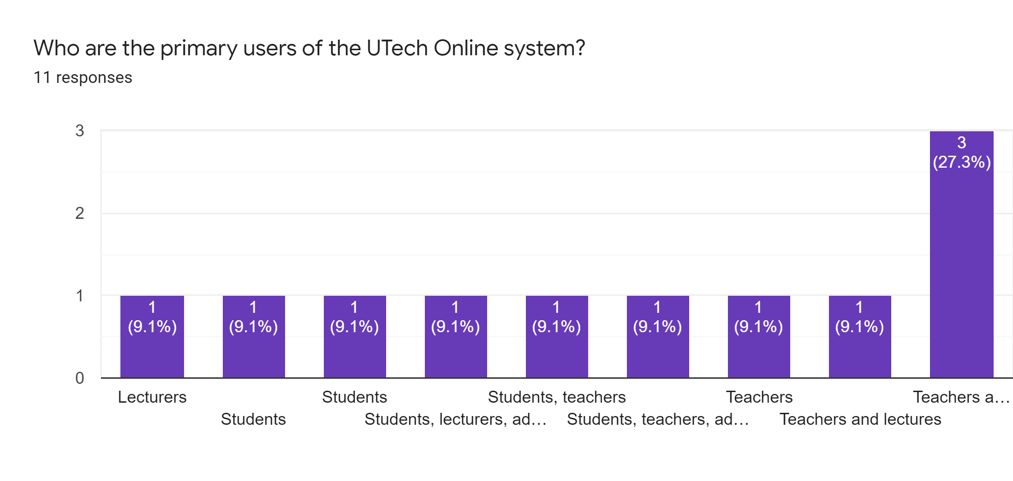

Based on the answers, it's fair to conclude that students and teachers are the key users of the Utech Online site.

1. How satisfied are you with the current UTech Online platform?

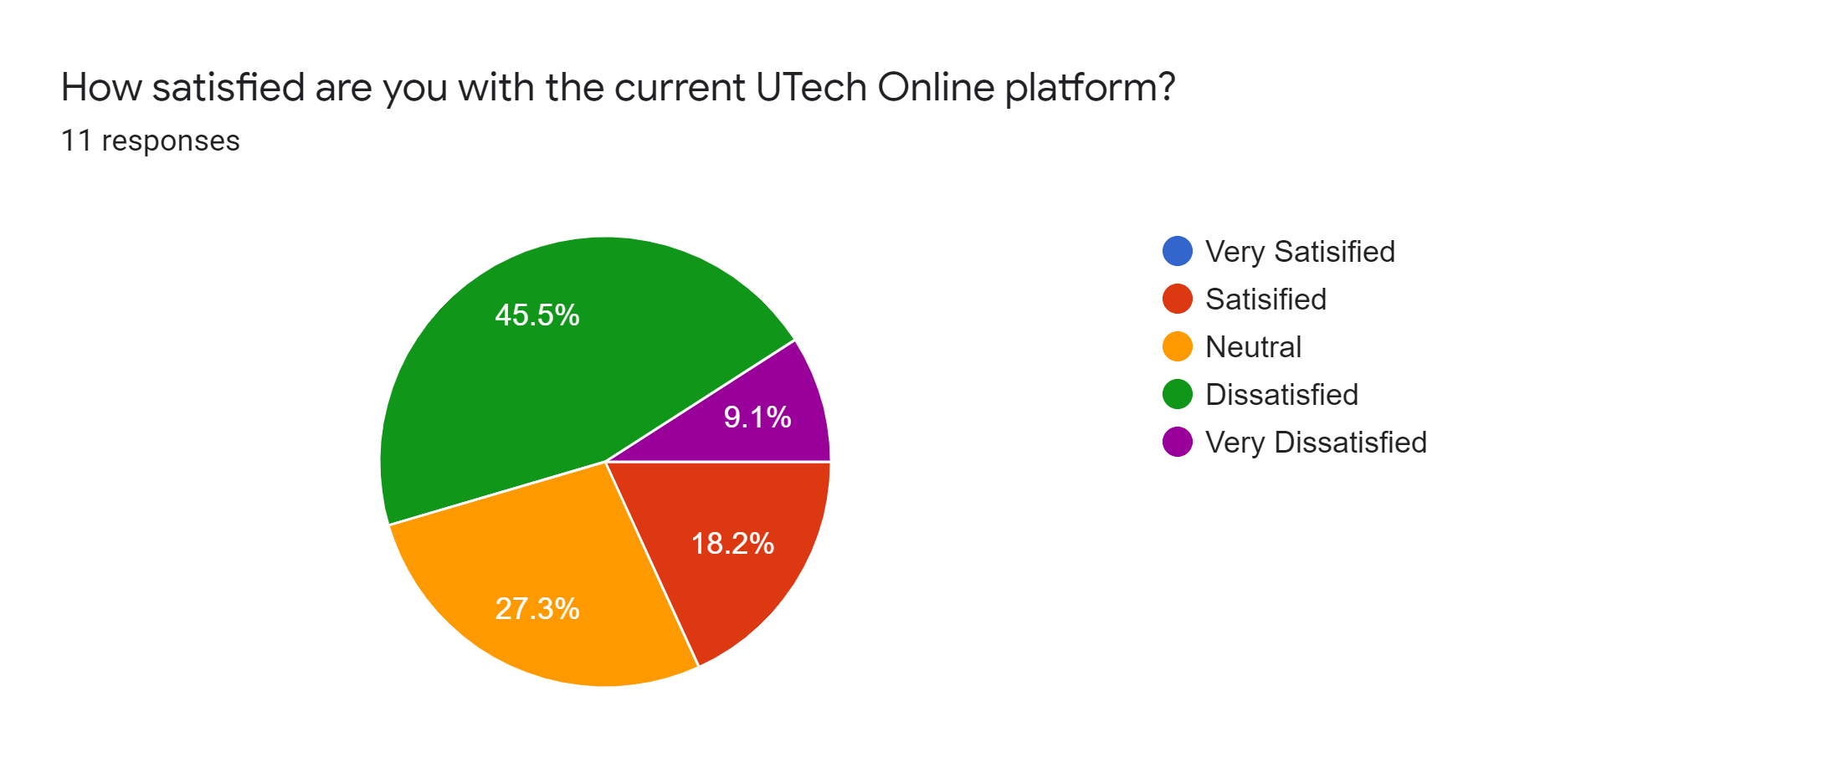

As it comes to satisfaction with the new UTECH website, 45.5 percent say they are unhappy, 27.3 percent say they are neutral, 18.2 percent say they are pleased, and 9.1 percent say they are really dissatisfied.

1. How is the interface design of the current UTech online platform?

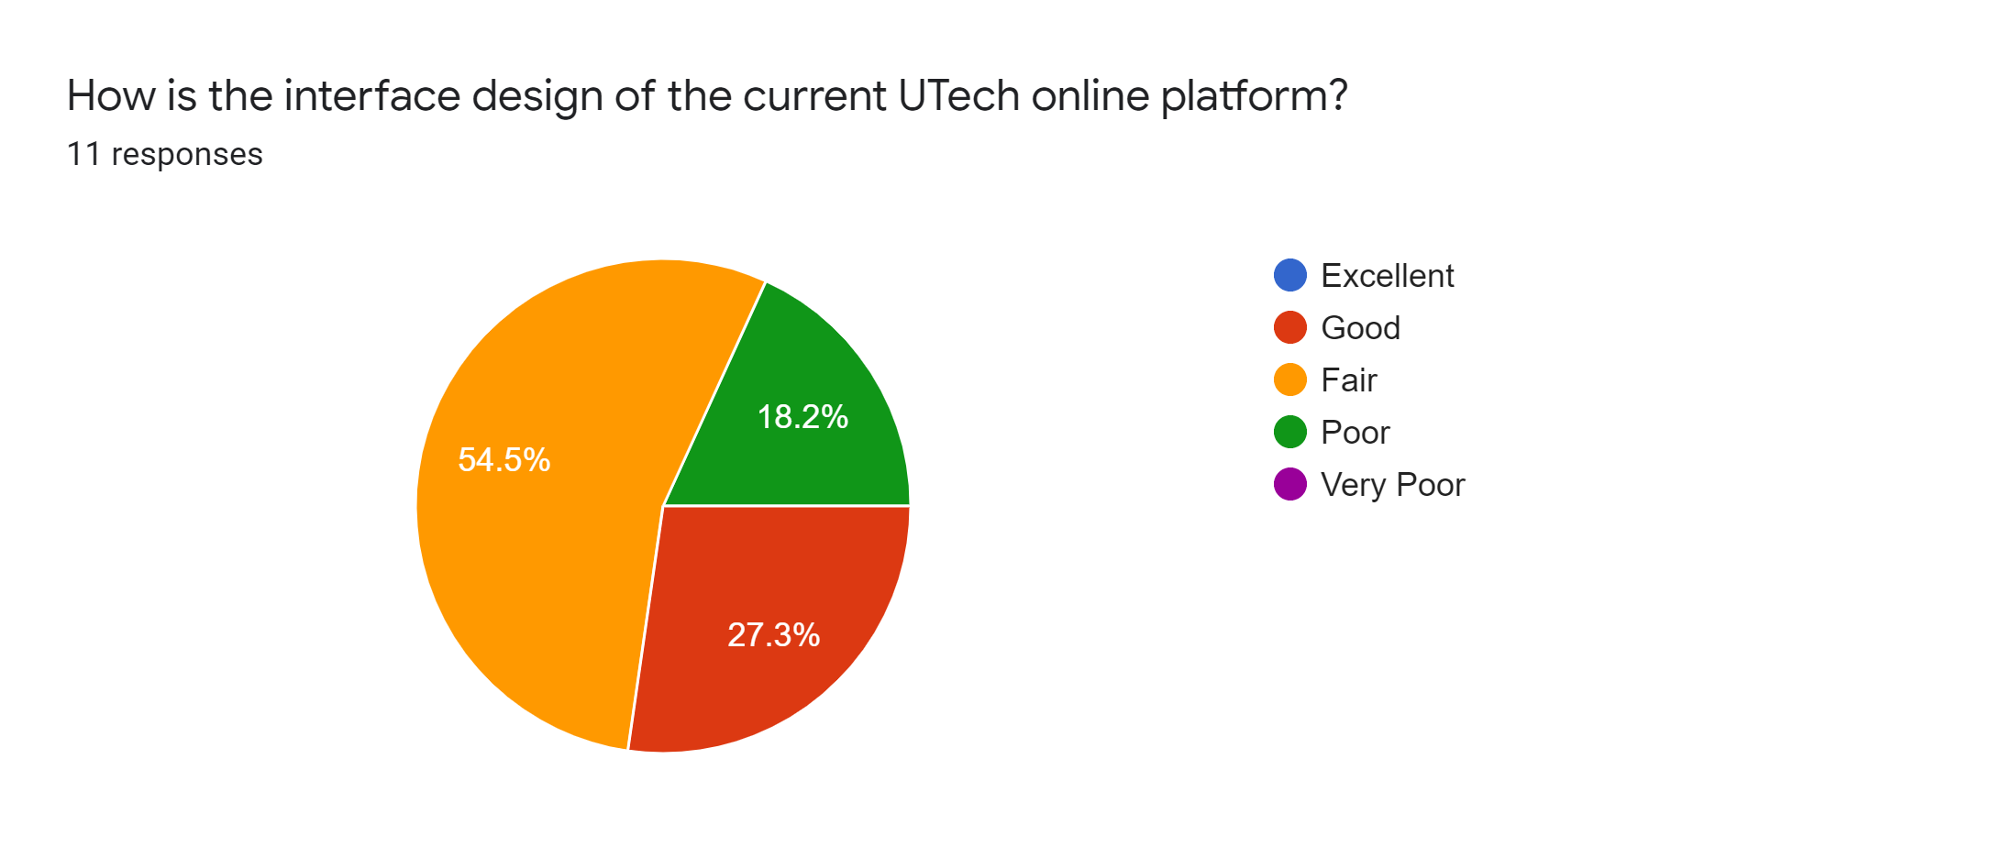

Regarding the new UTECH website's GUI design, 54.4 percent say it's fair, 27.3 percent say it's good, and the remaining 18.2 percent say it's poor.

1. On a scale of 1-10, how was your user experience (UX) of the current Utech Online platform?

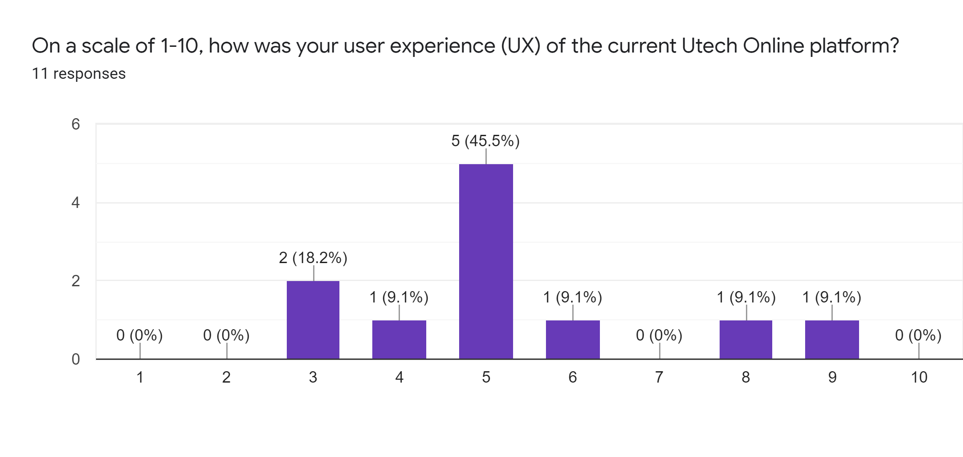

Centered on the scale above, it's fair to assume that 45.5 percent of users have a neutral experience with the website.

1. Is the website responsive and has a quick load time for the users?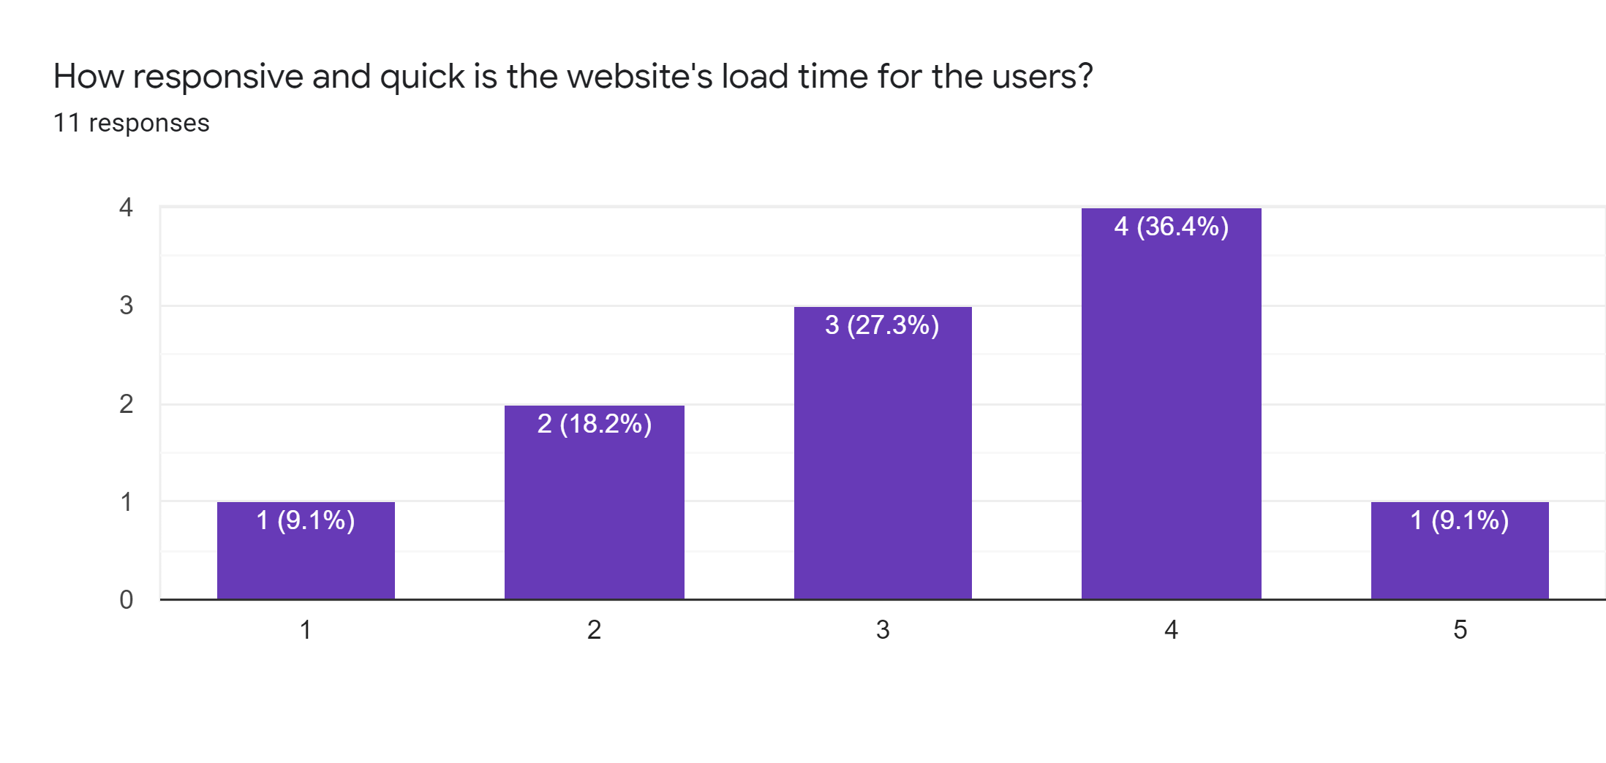

According to the bar graph, 36.4 percent of people are happy or satisfied with the responsiveness of the website load time, 27.3 percent are neutral, 18.2 percent are unhappy, and 9.1 percent are very satisfied and very dissatisfied with the responsiveness of the website load time.

1. Do you think the current UTech Online platform can be improved? If yes, what additional feature should be added?

The key external functionality that can be added to the website, according to the comments, includes a noticeable search option on the homepage. Furthermore, the respondents recommended that more bright colors and photos be used to improve the website's overall feel.

**Conclusion**

Based on the assessment issues, it is reasonable to assume that the system's key users are students and teachers. The majority of Utech Online users were unhappy with the system, indicating that it needed to be upgraded. More than half of those polled thought the interface design was fair. In terms of the website's user interface, the majority of respondents said it was satisfactory. The website was also reasonably strong in terms of usability and load time, according to the respondents. Finally, device users recommended that new enhancements such as transparent search and more vivid colors and photos be added to enhance the website's overall look and feel.